# ISTQB certification roadmap

**# Source**: **Chatgpt (GPT-5-Standard) at [8/14/2025]**

Here’s the **ISTQB certification roadmap** after **Foundation Level (FL)** — structured from beginner to expert:

## **1. Foundation Level (FL)**

**# Source**: **Chatgpt (GPT-5-Standard) at [8/14/2025]**

* **Purpose:** Entry-level, covering testing basics.
* **Variants:**
  + **Core Foundation Level** – General testing concepts.
  + **Foundation Level Agile Tester (FL-AT)** – Basics of testing in Agile environments.
  + **Foundation Level Mobile Application Testing (FL-MAT)** – Testing mobile-specific features.
  + **Foundation Level Automotive Software Tester (FL-AuT)** – For automotive industry software.
  + **Foundation Level Model-Based Tester (FL-MBT)** – Using models to design and execute tests.
  + **Foundation Level Performance Testing (FL-PT)** – Performance, load, and stress testing basics.
  + **Foundation Level Security Tester (FL-SEC)** – Basics of security testing.

## **2. Advanced Level (AL)**

**# Source**: **Chatgpt (GPT-5-Standard) at [8/14/2025]**

* **Purpose:** For experienced testers, test analysts, and managers.
* **Core Advanced Certifications:**
  + **Advanced Level Test Manager (AL-TM)** – Test planning, estimation, team leadership.
  + **Advanced Level Test Analyst (AL-TA)** – Designing functional tests.
  + **Advanced Level Technical Test Analyst (AL-TTA)** – Non-functional testing, white-box techniques.
* **Specialist Advanced Certifications:**
  + Advanced Level Security Tester (AL-SEC)
  + Advanced Level Test Automation Engineer (AL-TAE)
  + Advanced Level Test Process Improver (AL-TPI)

## **3. Expert Level (EL)**

**# Source**: **Chatgpt (GPT-5-Standard) at [8/14/2025]**

* **Purpose:** Highest ISTQB level — for senior professionals and leaders.
* **Modules:**
  + Improving the Test Process
  + Test Management
  + Test Automation
  + Security Testing (expert level in development)

### **Roadmap Flow**

**# Source**: **Chatgpt (GPT-5-Standard) at [8/14/2025]**

1. **Start:** Foundation Level → optional specialized Foundation modules (Agile, Mobile, etc.)
2. **Next:** Advanced Level (choose role-specific path: Test Manager, Test Analyst, Technical Test Analyst)
3. **Top:** Expert Level (focus on leadership, process improvement, automation mastery)

### **Visual Hierarchy**

**# Source**: **Chatgpt (GPT-5-Standard) at [8/14/2025]**

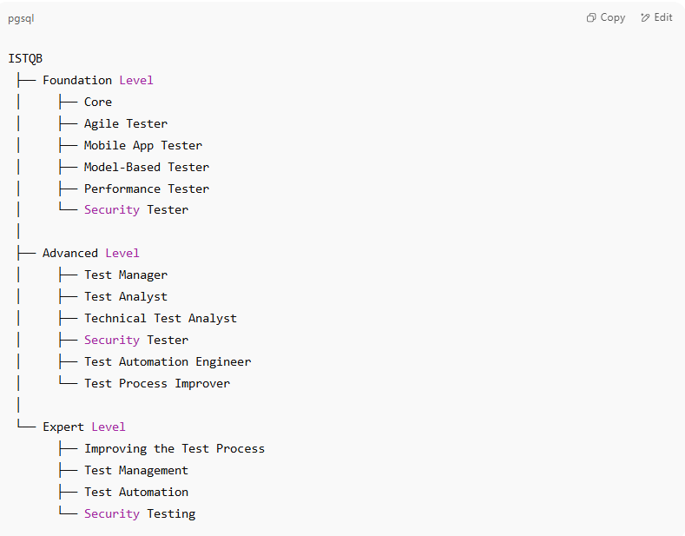

ISTQB

├── Foundation Level

│ ├── Core

│ ├── Agile Tester

│ ├── Mobile App Tester

│ ├── Model-Based Tester

│ ├── Performance Tester

│ └── Security Tester

│

├── Advanced Level

│ ├── Test Manager

│ ├── Test Analyst

│ ├── Technical Test Analyst

│ ├── Security Tester

│ ├── Test Automation Engineer

│ └── Test Process Improver

│

└── Expert Level

├── Improving the Test Process

├── Test Management

├── Test Automation

└── Security Testing